The Ottis Lock Endowment Award
for Higher Ed Educator of the Year

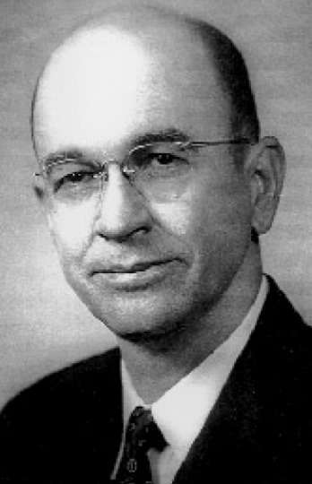
The Ottis Lock Educator of the Year Award seeks to recognize outstanding East Texans and their achievements as educators in libraries, museums, schools, colleges, and universities.
The applicant should provide all information requested and may feel free to provide additional supporting information.
Awards are presented at the ETHA annual meeting in Nacogdoches each October.
.

A nomination form is attached.
All nominations must be submitted BEFORE June 15 of each year.

The Ottis Lock Endowment Award
for Educator of the Year | Application/Nomination
Submission Deadline: June 15

Name:
Address:
Phone No:
Email:
Present Affiliation:
Address of Affiliation
Previous affiliations and experience:
Academic preparation (degrees, certificates, etc.):

Evidence of educator excellence:

(the nominator/applicant should provide a clear statement of achievement in education. No more than three letters of endorsement should be submitted in support of the nomination application)

All nominations must be submitted BEFORE June 15 of each year. Completed nominations should be emailed to sosbeem@sfasu.edu, or mailed to:

Ottis Lock Endowment Committee
East Texas Historical Association
Box 6223, SFA Station
Nacogdoches, TX 75962-6223

