The Ottis Lock Endowment
Research Grants

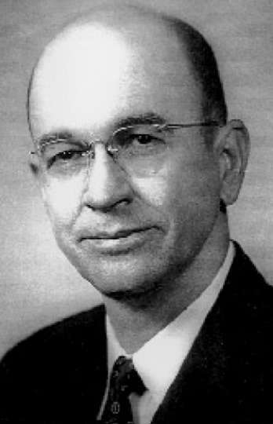
A number of research grant awards for projects focused on East Texas history will be made annually, usually in amounts of $500 to $1000.
Applications should include name and address of the researcher (with biographical data), the purpose for which the funds would be spent, and a general statement of anticipated benefit and uses
Completed applications should be submitted before June 15 of each year, and emailed to sosebeem@sfasu.edu, or mailed to:

Ottis Lock Endowment Committee
East Texas Historical Association
Box 6223, SFA Station
Nacogdoches, TX 75962-6223

A nomination form is attached.

The Ottis Lock Endowment Research Grants
Application/Nomination
Submission Deadline: June 15

Project Title:
Name of Principal Investigator::
Address:
Phone No:
Email:
Names and addresses of others associated with the project:
Sponsoring Institution,
if any:
Address for Institution:
Biographical and professional record of principal investigator and others associated with the project:
Statement of purpose for which funds will be expended:
General statement of anticipated benefit of expenditure:
Statement of usefulness of research if completed

All nominations must be submitted before June 15 of each year. Completed nominations should be emailed to sosbeem@sfasu.edu, or mailed to:

Ottis Lock Endowment Committee
East Texas Historical Association
Box 6223, SFA Station
Nacogdoches, TX 75962-6223

